

ST MARY’S DSG, KLOOF

GRADE: 10 17 October 2025

PHYSICAL SCIENCE CYCLE TEST
KINEMATICS AND ELECTRICITY

TIME: 55 MINS (incl. reading time) TOTAL: 63
ASSESSOR: T. Kirsten MODERATORS: K. Bolton and G. Main

NAME: ________________________________

SCIENCE TEACHER: ______________________________________________

PLEASE READ THE FOLLOWING INSTRUCTIONS CAREFULLY
- This question paper consists of 8 pages. A data sheet is provided.
- Answer on the question paper in the spaces.
- Write your name and your science teacher’s name on your question paper.

SECTION A: KINEMATICS
QUESTION 1
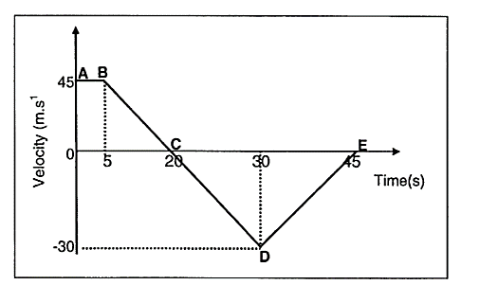
The velocity-time graph of a train initially moving in a SOUTHERLY direction is shown below. The graph is NOT drawn to scale.

  - Describe the motion of the train for the following time intervals, in terms of velocity and acceleration. (8)
1.1.1 B to C

1.1.2 C to D

1.2 Without the use of equations of motion, calculate the total displacement for the time interval A-E. (6)

1.3 Sketch an acceleration vs time graph for the train over the entire journey. Indicate all relevant time values. Acceleration values are not necessary. (4)

[18]

QUESTION 2
Athletes A and B are training on a straight, level track.
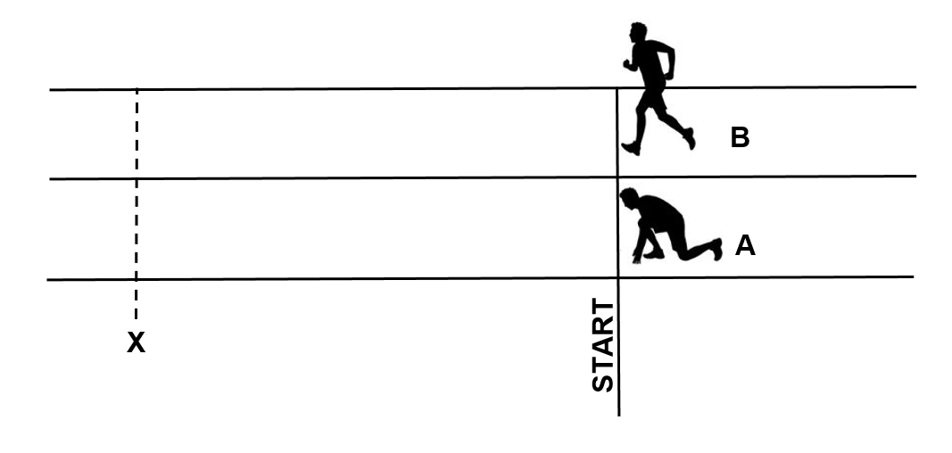

- Athlete A starts from rest from the position shown.
- Athlete A accelerates to the left at 0,4 m·s⁻².
- Athlete B is running to the left at a constant velocity of 2 m·s⁻¹.
- At the instant that athlete A starts, athlete B passes athlete A.

2.1 Determine the time at which A and B are in the same position X. (4)

2.2 Determine the magnitude of the displacement of the athlete A at point X, taking the start as the reference position. (3)

- Athlete A accelerates at 0,4 m·s⁻² for 12 s.
- She then continues to run to the left at constant velocity for a further 10 s.
- She then comes to rest over another 10 s.

2.3 In the space below, draw a position-time sketch graph for athlete A for the full 32 s of her run. Take left as positive and use the start as the reference point.
No values need to be shown on the y-axis but you should label times on
the x- axis. (5)

Athlete B decides to slow down when passing point X and comes to rest during a time of 7 s.

2.4 Define acceleration. (2)

2.5 Calculate the acceleration of athlete B during this time period. (4)

[18]

SECTION B: ELECTRICITY
QUESTION 3 MULTIPLE CHOICE Circle the most correct letter

3.1 Identical resistors are connected together to form arrangements X, Y and Z.
What is the correct order of the total resistances of the arrangements from the largest to the smallest?
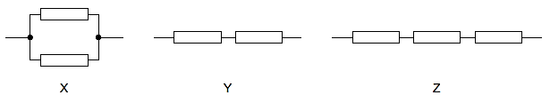
A X → Y → Z
B Y → X → Z
C Z → X → Y
D Z → Y → X

3.2 Consider the diagram below:
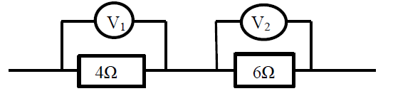

If a current is flowing through both resistors;

A V₁ will have a higher reading than V₂
B V₂ will have a higher reading than V₁
C the reading on V₁ and V₂ will be the same
D potential difference is inversely proportional to resistance.

2 x 2 = [4]

QUESTION 4
A 18 V battery is connected in a circuit as shown in the diagram below.
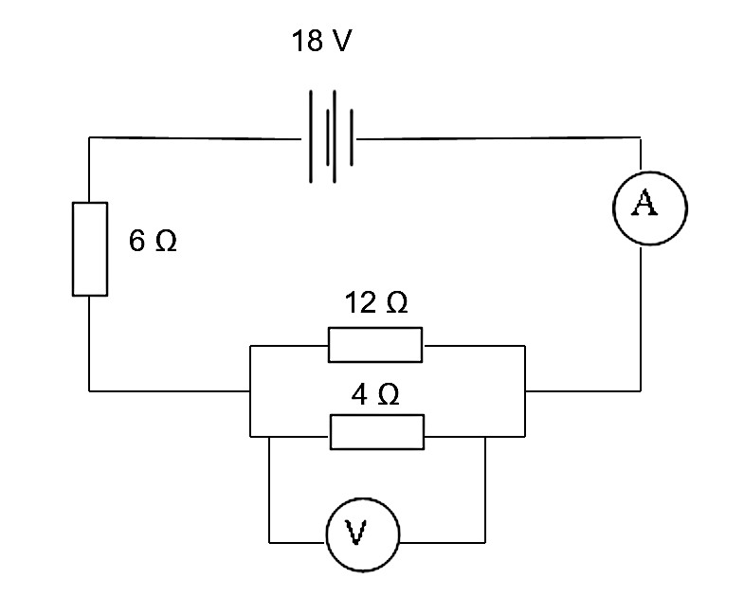

4.1. Define resistance. (2)

4.2 Calculate:

4.2.1 the resistance of the parallel combination (3)

4.2.2 the total resistance of the given circuit (2)

4.3 Define current. (2)

4.4 Calculate:

4.4.1 the reading on the ammeter (2)

4.4.2 the time it takes for 17 C of charge to pass a point in the above circuit. (3)

4.5 Define potential difference. (2)

4.6 Calculate:

4.6.1 the reading on the voltmeter (3)

4.6.2 the work done in moving 5 Coulombs of charge through the 6 Ω resistor. (4)

[23]

